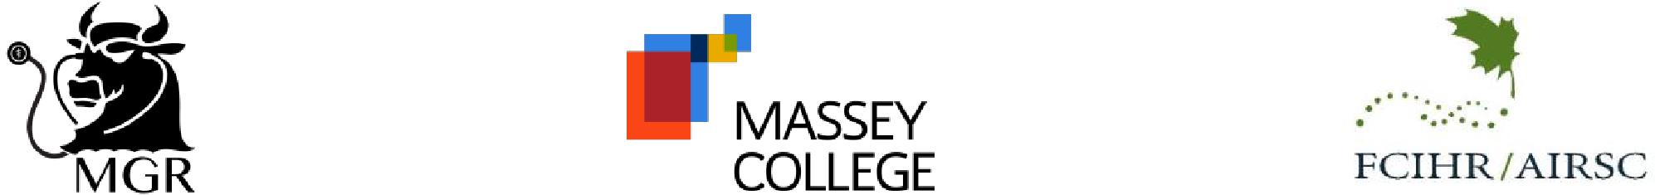

**THE JANET ROSSANT LECTURESHIP   
2025 NOMINATION FORM**

**PREAMBLE:**

*The Janet Rossant Lectureship was established at Massey College in recognition of Dr. Janet Rossant's distinguished career as a scientist, scholar, builder and leader in medical research. This, coupled with her dedicated mentorship of young scientists and scholars, is reflected in the purpose of this honour. This honorific Lectureship will attract accomplished visiting scientists to engage graduate students and faculty members alike, as part of the Massey Grand Rounds (MGR) program at Massey College. Terms of Reference for the Award are attached.*

**Award:**

The Award consists of a cash prize of $2,000 CAD plus economy air fare, hotel and hospitality costs associated

with the fulfillment of the Lecture and in-person participation in the annual MGR Symposium.

A suitable memento commemorating the honour is presented.

**NOMINEE:____________________________** Title: _____________________________________

Address: Postal Code/Zip: ____________

Phone: ( ) E-Mail: _____________________

**BASIS OF THE NOMINATION:**

Please provide key information regarding the nominee’s career and stature, major contributions to health

research, health policy and care and any other distinguishing accomplishments.

**Nominator:**

Name: Signature: ________________________________________

Date: ____________ Phone**: ________________** E-Mail: _______________________________

**The following additional information is required to accompany this form:**

* Curriculum Vitae and List of Publications of the Nominee
* Letter of endorsement from nominator

**Pease send the completed Nomination Package by email to** [**FCIHR.jrl@gmail.com**](mailto:FCIHR.jrl@gmail.com) **by February 7, 2025 marked CONFIDENTIAL to the attention of:**

***The Janet Rossant Lectureship – Advisory Committee***

**c/o Dr. Peter N. Lewis (Chair)**