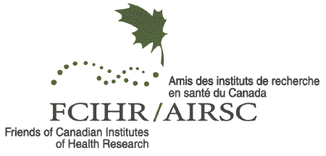
Application for Membership

The Friends of Canadian Institutes of Health Research was created to promote the value of health research and establish community-based partnerships. Since 2000, it has specifically supported the goals of the Canadian Institutes of Health Research (CIHR) and has expanded its role to represent all health disciplines. Members are active in universities, hospitals, voluntary organizations, community groups and agencies, as well as health-related corporations.

The objectives of the Friends of CIHR are to:

- Support the goals and values of Canadian Institutes of Health Research (CIHR)
- Communicate the benefits of Health Research to a broad audience
- Facilitate a sharing of health care and health research knowledge through public forums
- Attract and support health research trainees in their career development

To achieve these goals FCIHR recruits individuals across all health disciplines and beyond.

Information:

(Completion of this form ensures FCIHR records are accurate and current. Your personal and professional data is used only for the sharing of FCIHR information with you and is not published, distributed or provided to any other parties without your express permission.)

Name:
Title:
Department:
Mailing Address:
City & Province: Postal Code:
Phone: (____) ______-__________ ext______

E-mail Address:

Previous Relationships (if any) to CIHR and its Councils and Committees (check all that apply):

[ ] Graduate Student [ ] Clinician-Scientist Fellow [ ] Career Investigator [ ] Grantee
[ ] other ______________________________________________

Signature Date

Please send the completed form to FCIHR.memb@gmail.com

Your application will be assessed by the FCIHR Governance and Nominating Committee and if approved, you will be informed and sent an annual invoice (Jan 1 through Dec 31) for $100 to your email address. Should you have any questions don’t hesitate to contact us at FCIHR.memb@gmail.com

