THE FRIENDS OF CIHR FOUNDERS’ AWARD
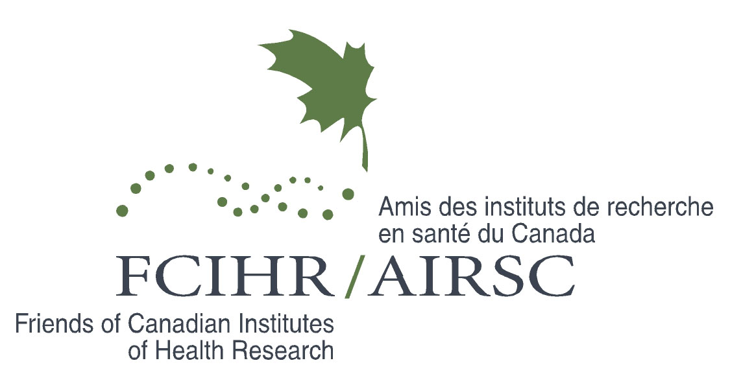

Nomination Form

THE FRIENDS OF CIHR FOUNDERS’ AWARD
Presented in recognition of significant contributions to the mission of FCIHR

This Award newly introduced in September 2010 recognizes an individual of high scientific achievement who has advanced the fields of research and/or enterprise in Canadian Biomedicine. Individuals who have been involved in the early phase of the establishment of FCIHR and prior to that, Alumni & Friends of MRC, are candidates for this recognition. The Executive of FCIHR will advise the President on a suitable candidate.

THE AWARD
The Award includes an invitation to speak in a scientific Forum, designated as the “Founders’ Award Lecture”.

Nominator: |  | Nominee:
Organization: |  | Organization:
Address: |  | Address:
City: |  | City:
Province: |  | Province:
Postal Code: |  | Postal Code:
Phone: |  | Phone:
Fax: |  | Fax:
Email: |  | Email:

Reason for Nomination (please use additional pages):

Please submit this form and the Nominee's résumé to:
Awards Committee, Friends of CIHR
4 Devonshire Place, Toronto, Ontario M5S 2E1
Tel. & Fax #: (416) 506-1597
Email: FriendsofCIHR@gmail.com

